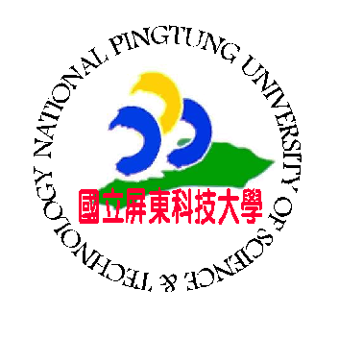
Certificate of Attendance
範例
Cert. No. 2026062401
This is to certify that Lin, Ma Li (林瑪莉), has successfully
completed a five-day course of Artificial Insemination on Pigs (Advanced 2)
at the Innovation and Practical Training Center from July 25 to July 29, 2005.

Given under the seal of the National Pingtung University of Science and Technology,
Taiwan, the Republic of China,

June 24,2026
Date Dr. Chin-Lung Chang
President
National Pingtung University of Science and Technology

