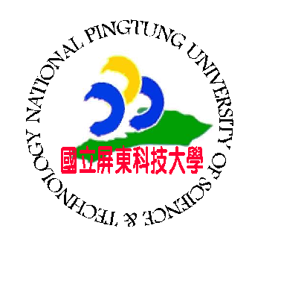
Certificate of Appreciation
範例

Cert. No. 2026062401
This certificate is proudly presented to
Ms. Ma-Li Lin (林瑪莉)
in sincere recognition and deep appreciation for your outstanding contribution and generous support to National Pingtung University of Science and Technology. Your dedication and hard work have made a significant impact on our success.

June 24,2026
Date Dr. Chin-Lung Chang
President
National Pingtung University of Science and Technology

